***Parquet format:***

Parquet is a columnar format storage designed specifically for the big data eco-systems.it was developed by apache and is optimized for tools like:

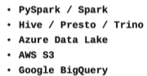

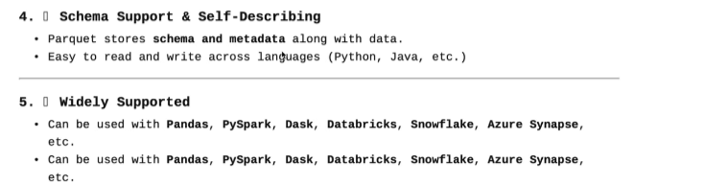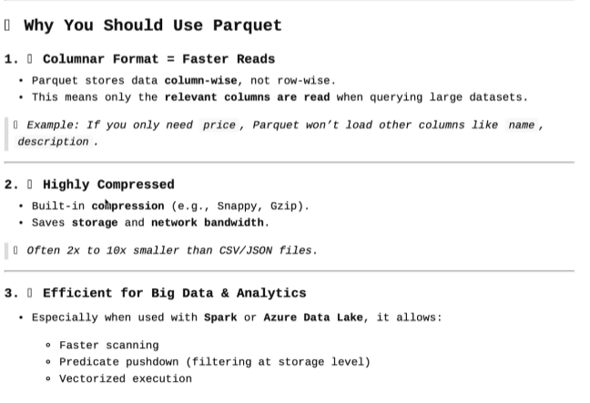

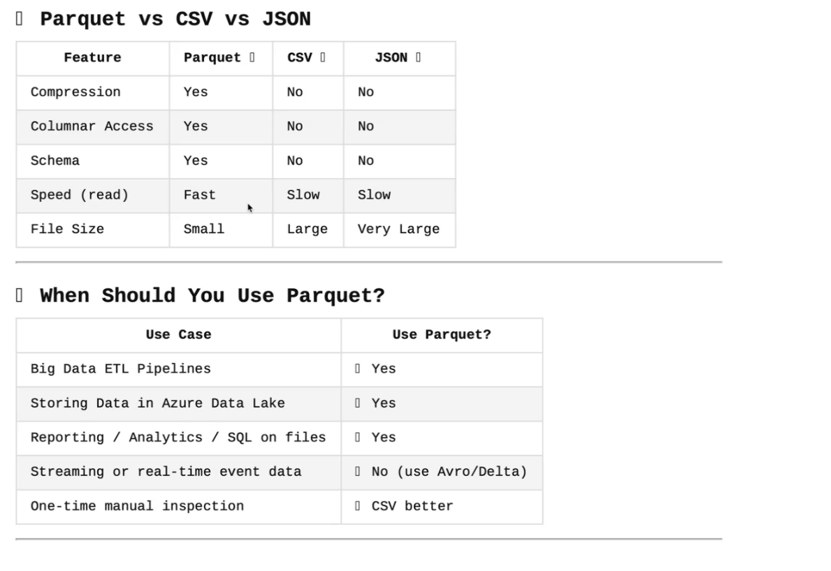

**DELTA FORMAT:**

It is a data format ,that is used on real data streaming and in big data.

